How to Resize Thin Provisioned Linux VMDK via VMware Converter

*By Jacky.Zho, Double.Lin 20241002*

1. **Purpose**: Reduce Linux Thin_Provisioned VMDK size from 180GB to 18GB.
2. Download “VMware vCenter Converter 6.6.0” from VMware portal, v6.6 & Install  
   <https://support.broadcom.com/group/ecx/productfiles?subFamily=VMware%20vCenter%20converter&displayGroup=Standard&release=6.6.0&os=&servicePk=203348&language=EN>  
   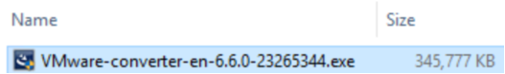  
   Note: Use default “Local installation”   
   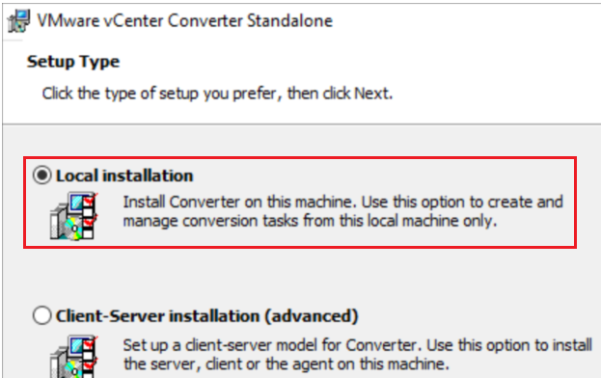
3. Start converting:
   1. 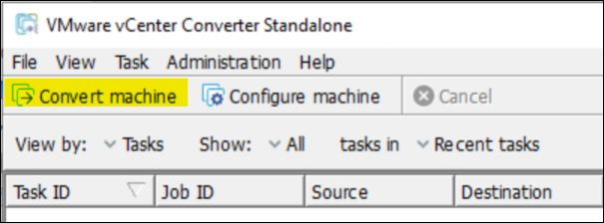
   2. Configure Source information:   
      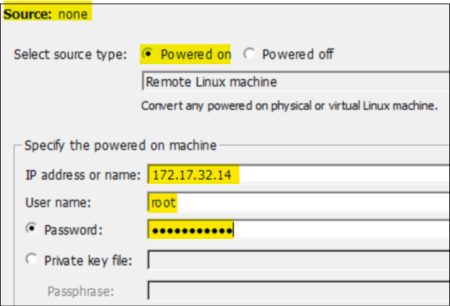
   3. Destination information: its vCenter IP/Credential, check Source OS version is detected as below red words.  
      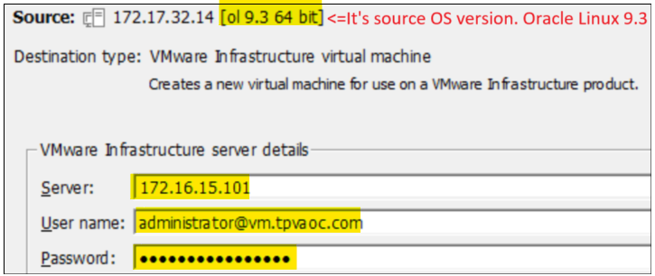
   4. Type new VM Name:  
      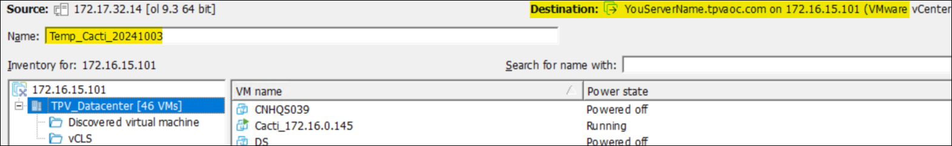
   5. Select destination host & Data Store & VM HW version (from v19 to v17 to get better support)  
      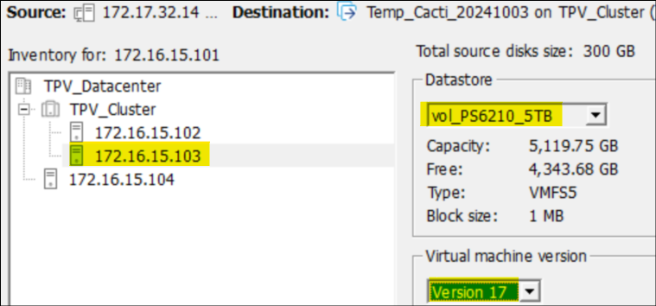
   6. Change disk setting => Click Advance  
      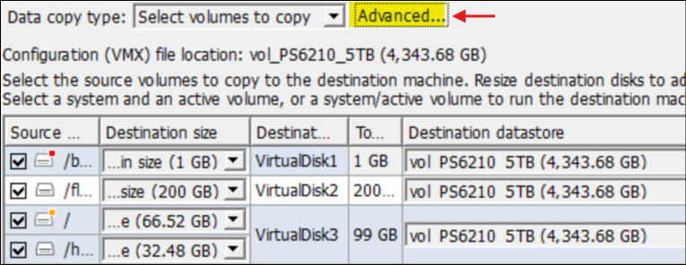  
      Change type from Thick => Thin, Change disk size 69G =>89GB & 30GB => 10GB  
      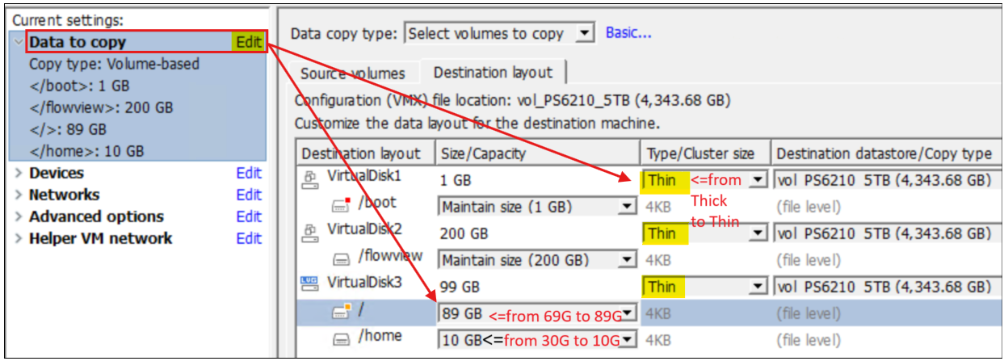  
      Click “Devices” => Edit => modify correct Socket and core qty.  
      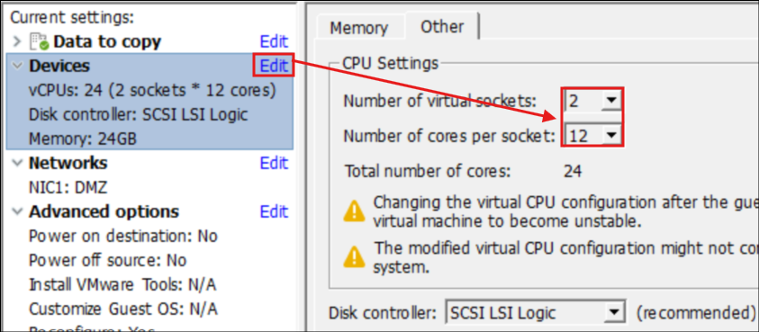  
      Click “Network” => Edit =>MUST select correct Network & VMXNET3  
      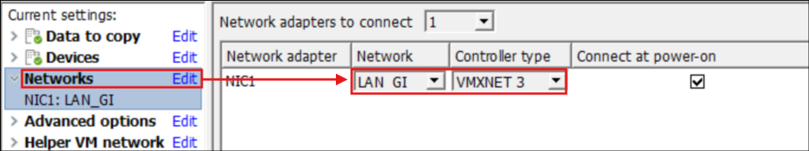  
      Click “Helper VM network” =>Edit => Configure IPv4 & DNS => Click “Next”  
      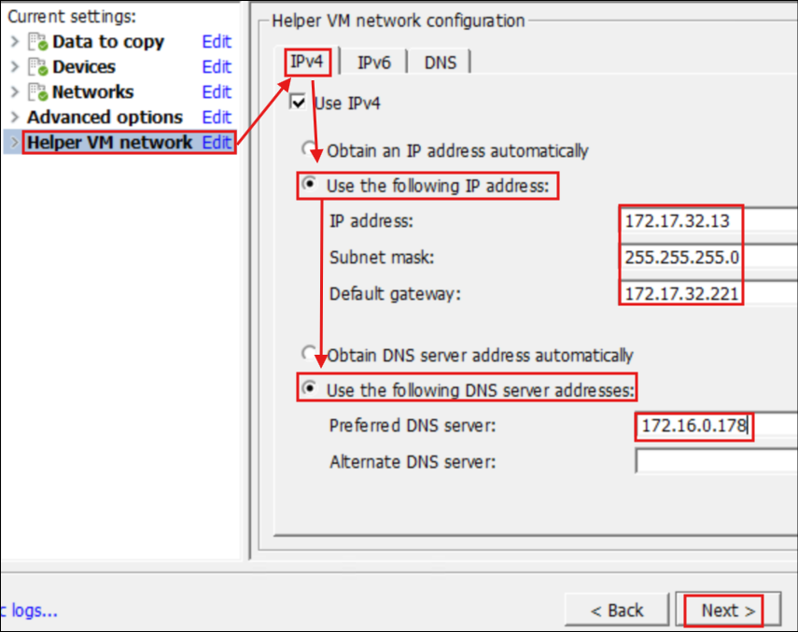  
      Check previous configurations are correct => Click Finish.  
      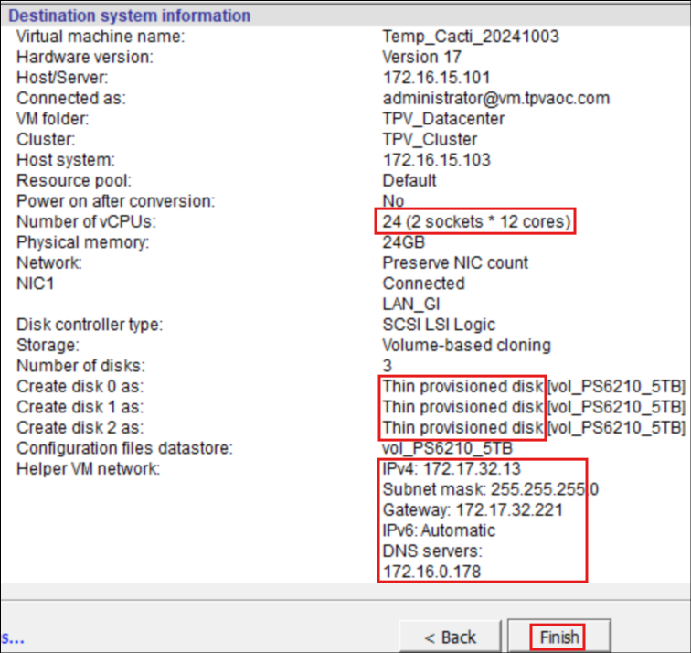
   7. Start converting, completed rate 2% is checking point. >2% will get higher success rate.  
      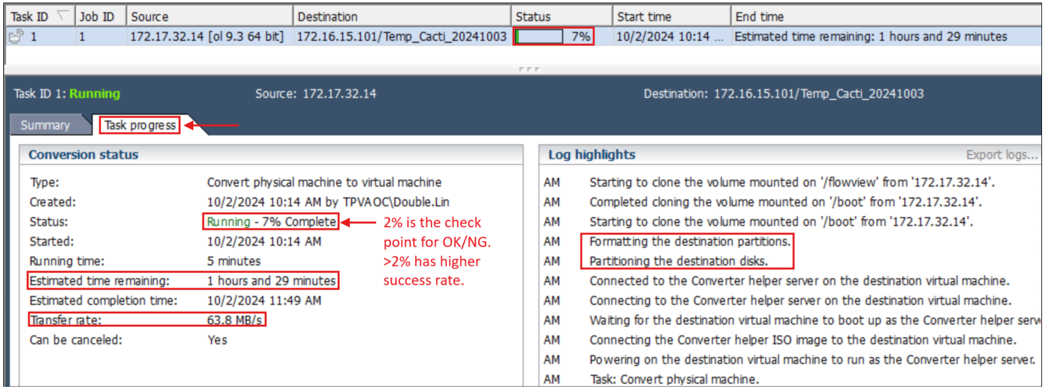
   8. Completed of converting.  
      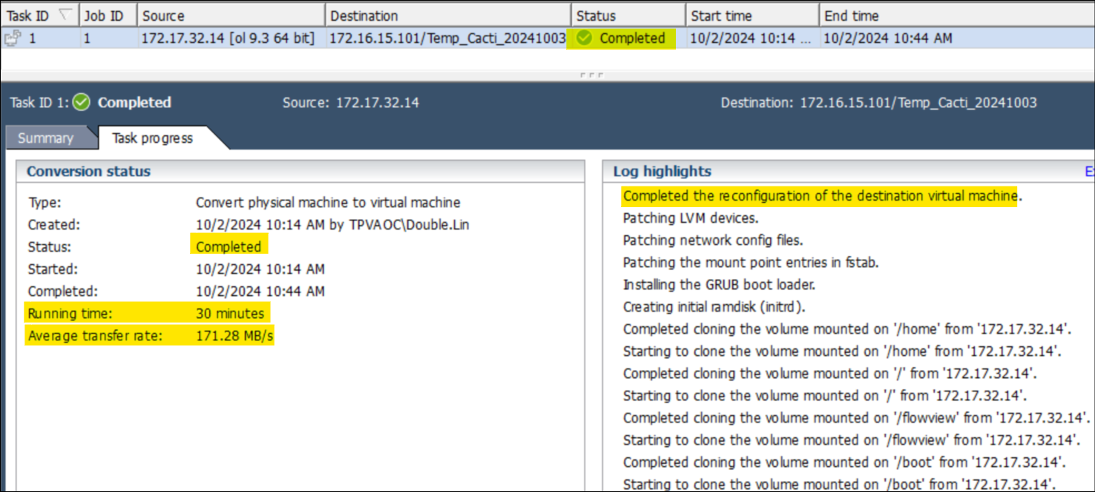
   9. Check VMDK size
4. Troubleshooting:  
   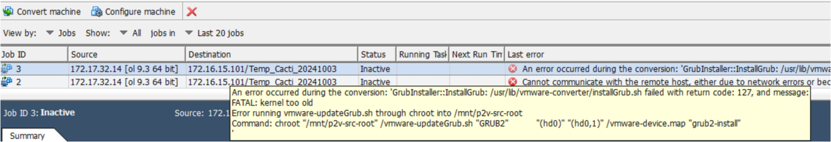
   1. Cannot create Linux booting GRUB2: Reinstall VMware converter version from v6.2 v6.6.
   2. Helper IP cannot connected: Setup Helper IP as below  
      